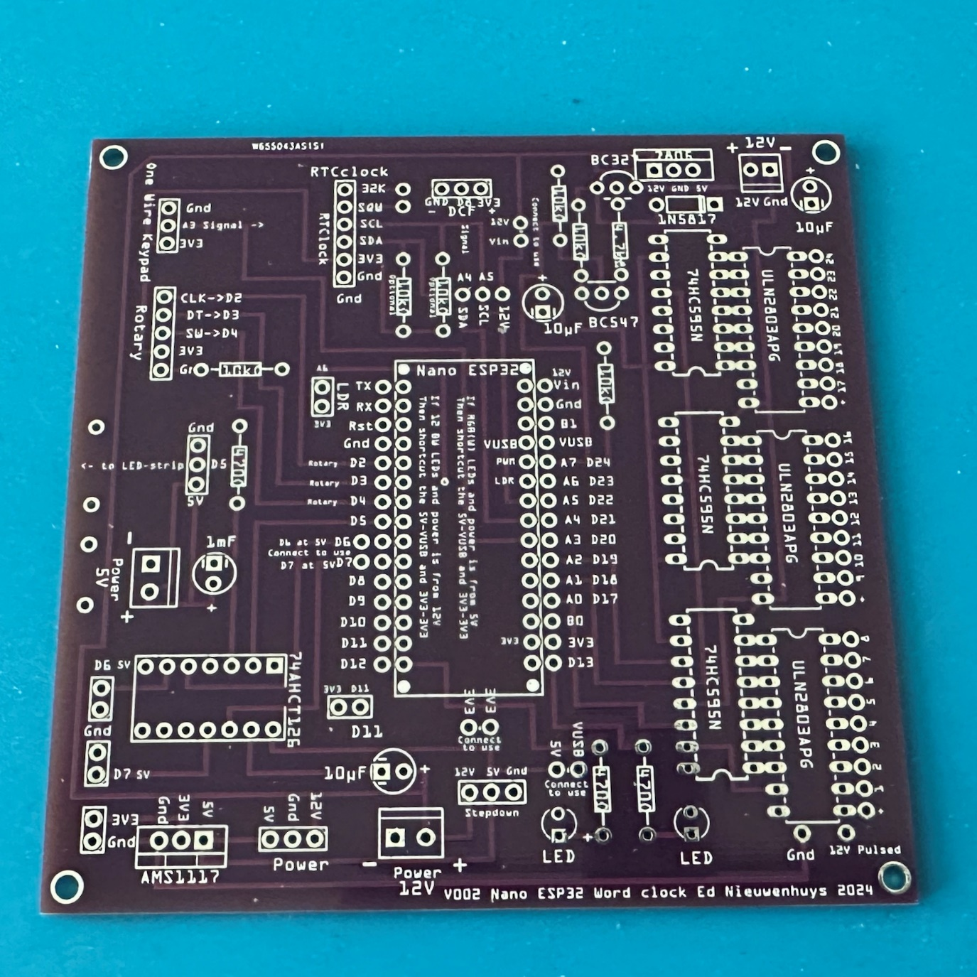

The empty PCB.

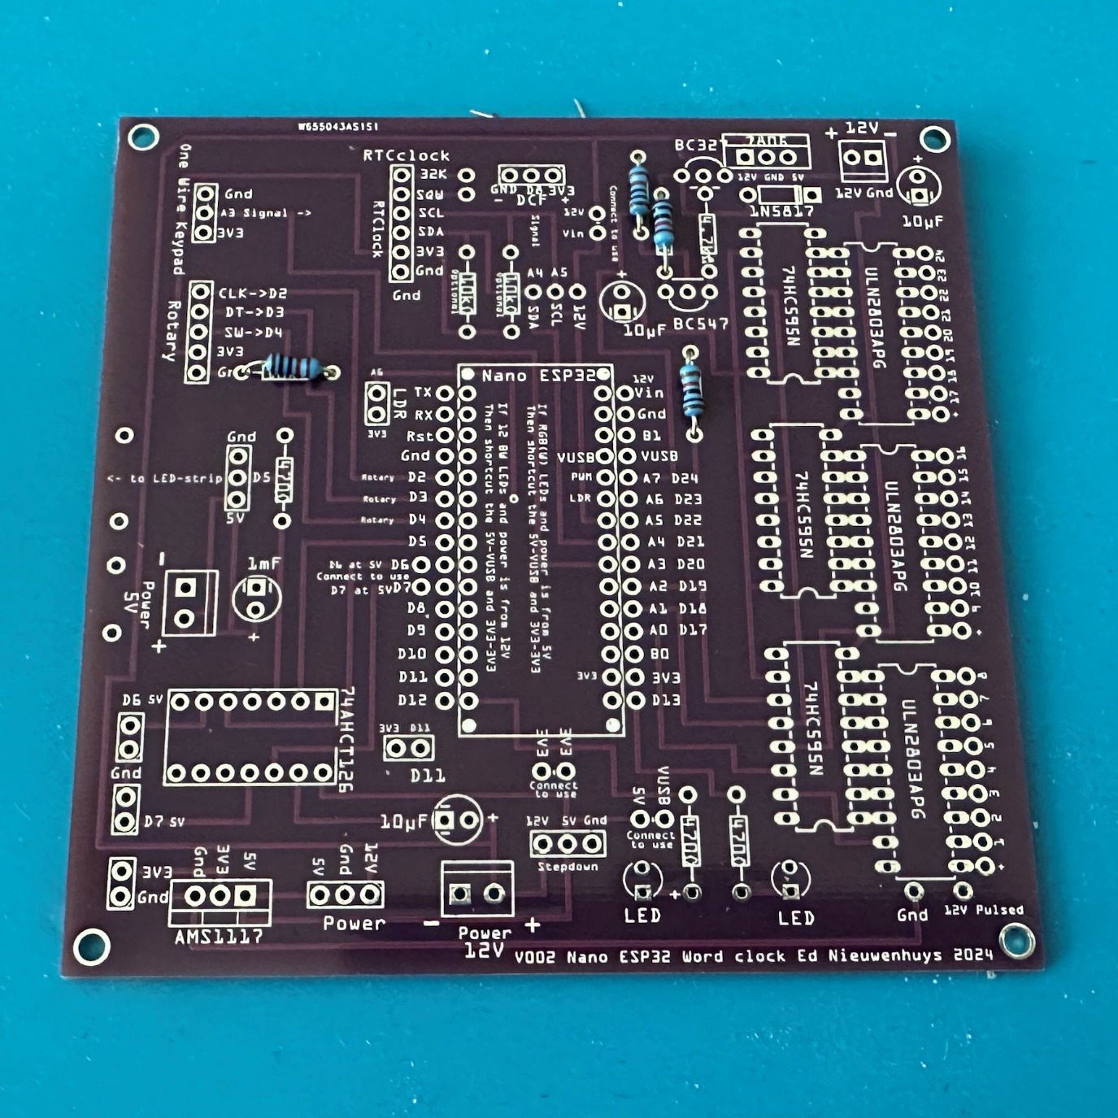  
  
Solder four 10 KΩ resistors

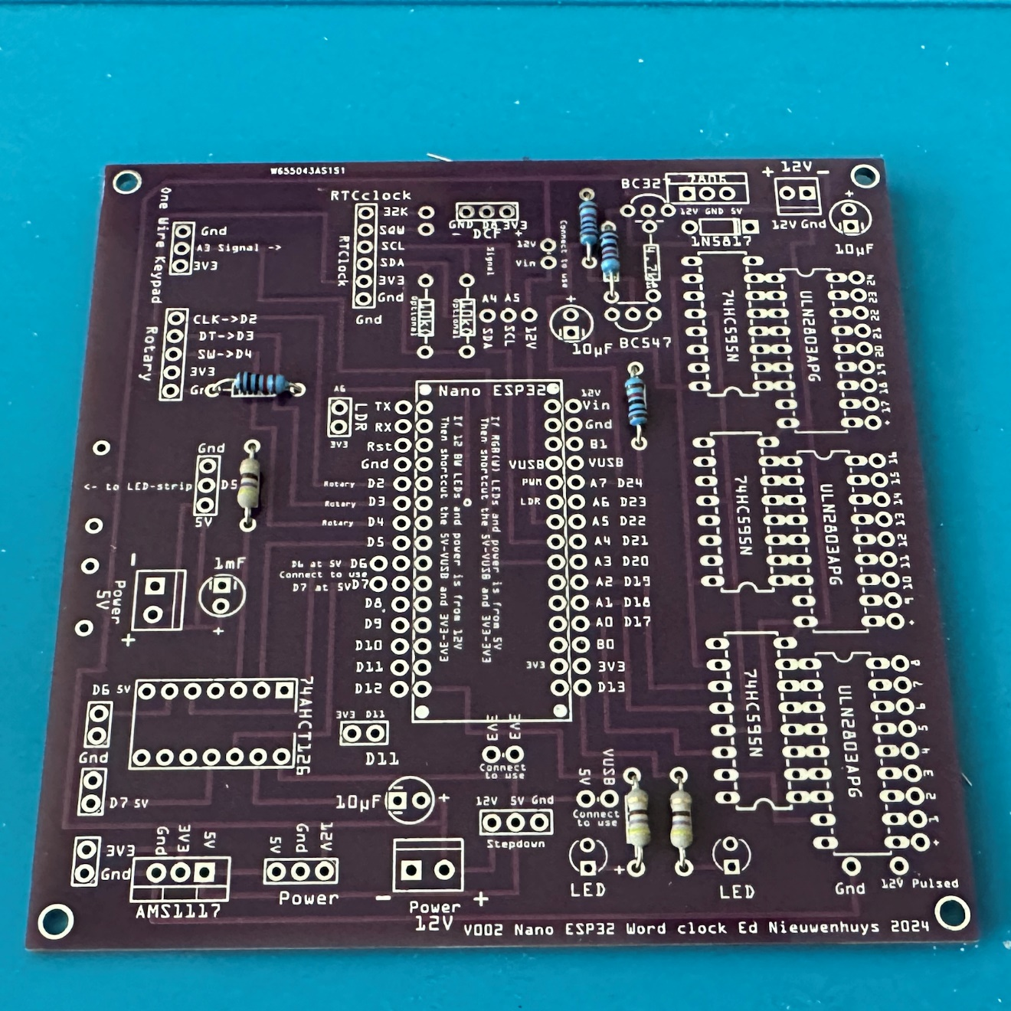  
  
Solder three 470 Ω resistors 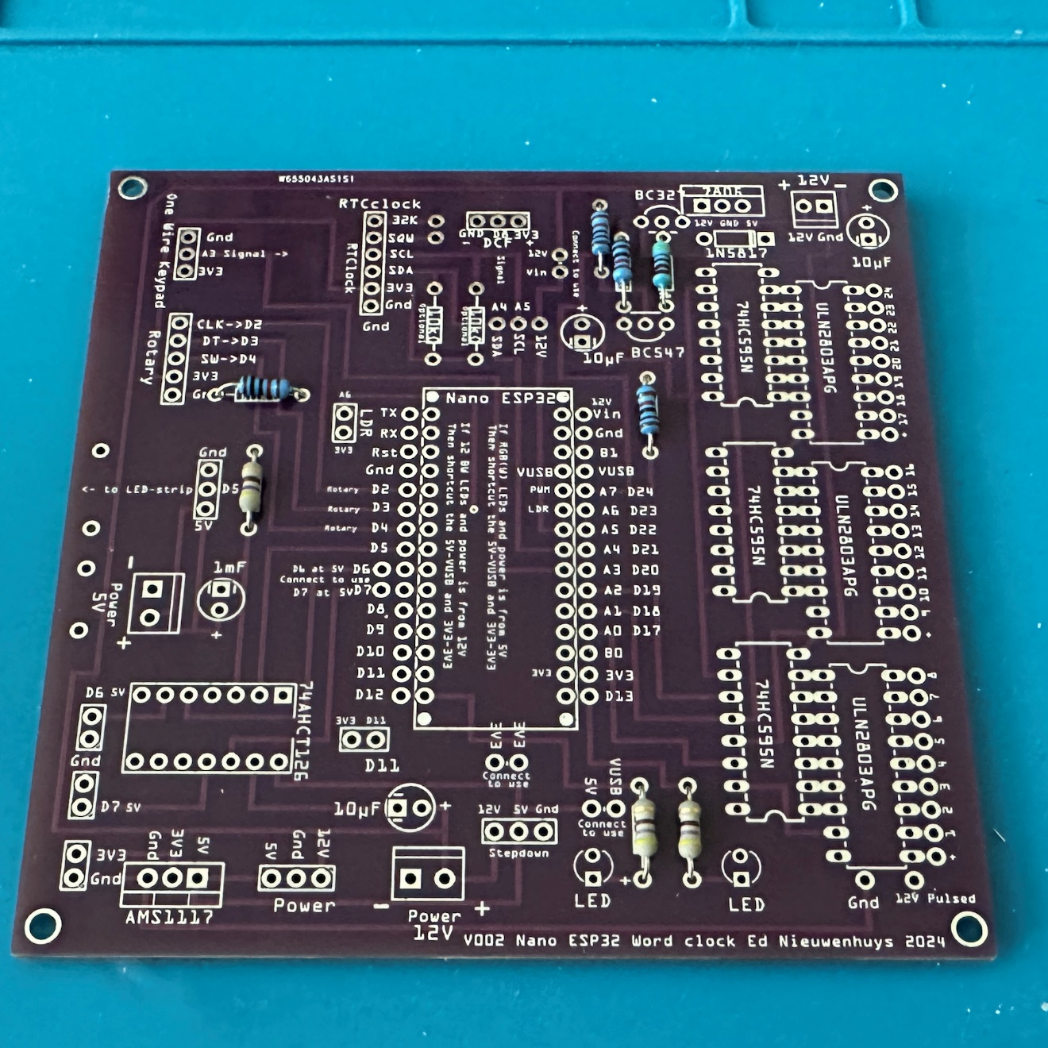  
  
Solder one 4.7 kΩ resistor

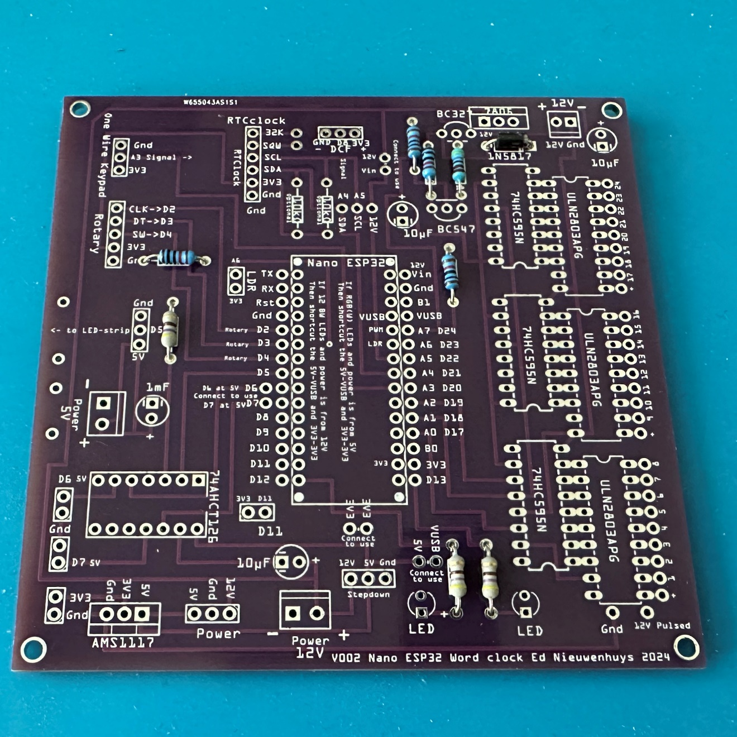  
  
Solder one V002 or two V003 1N5817 diode  
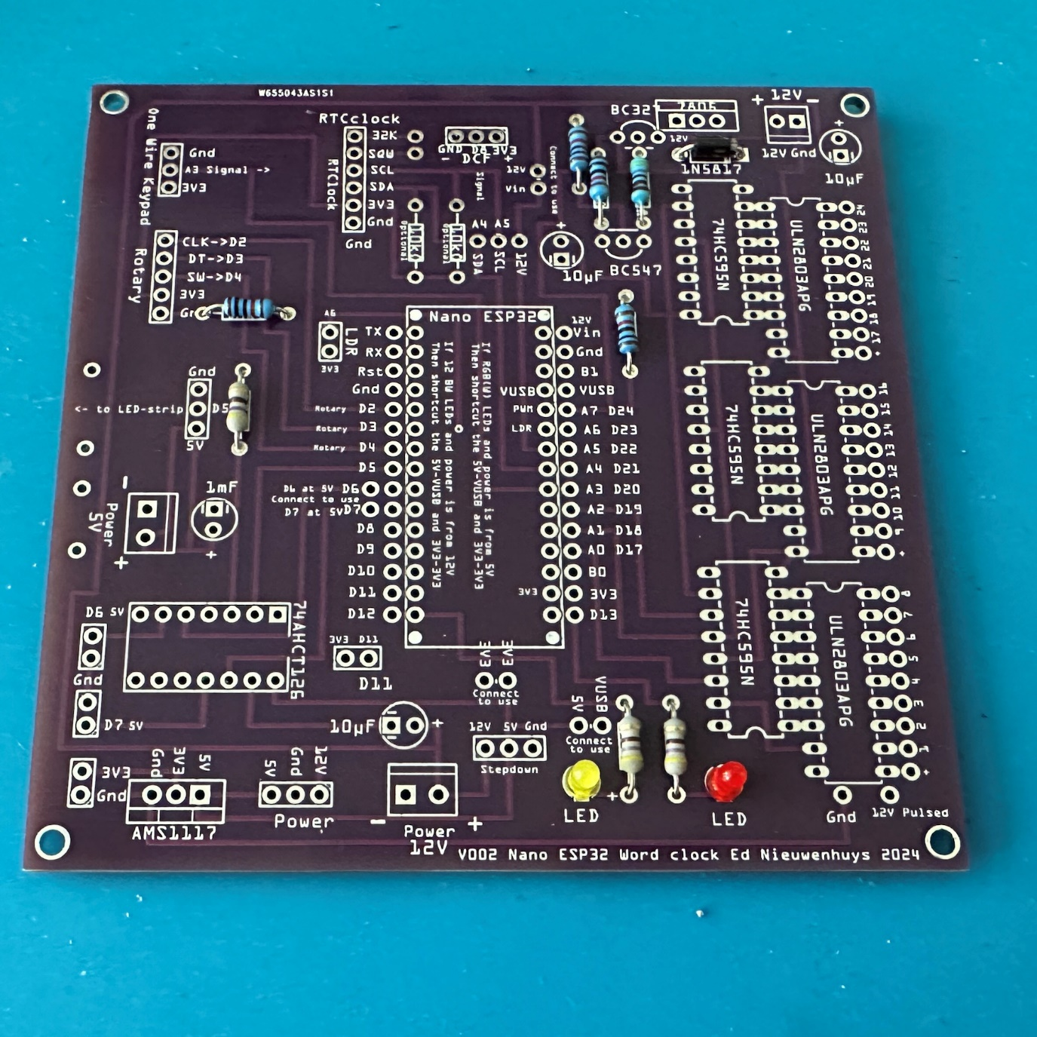  
  
Solder two LEDs  
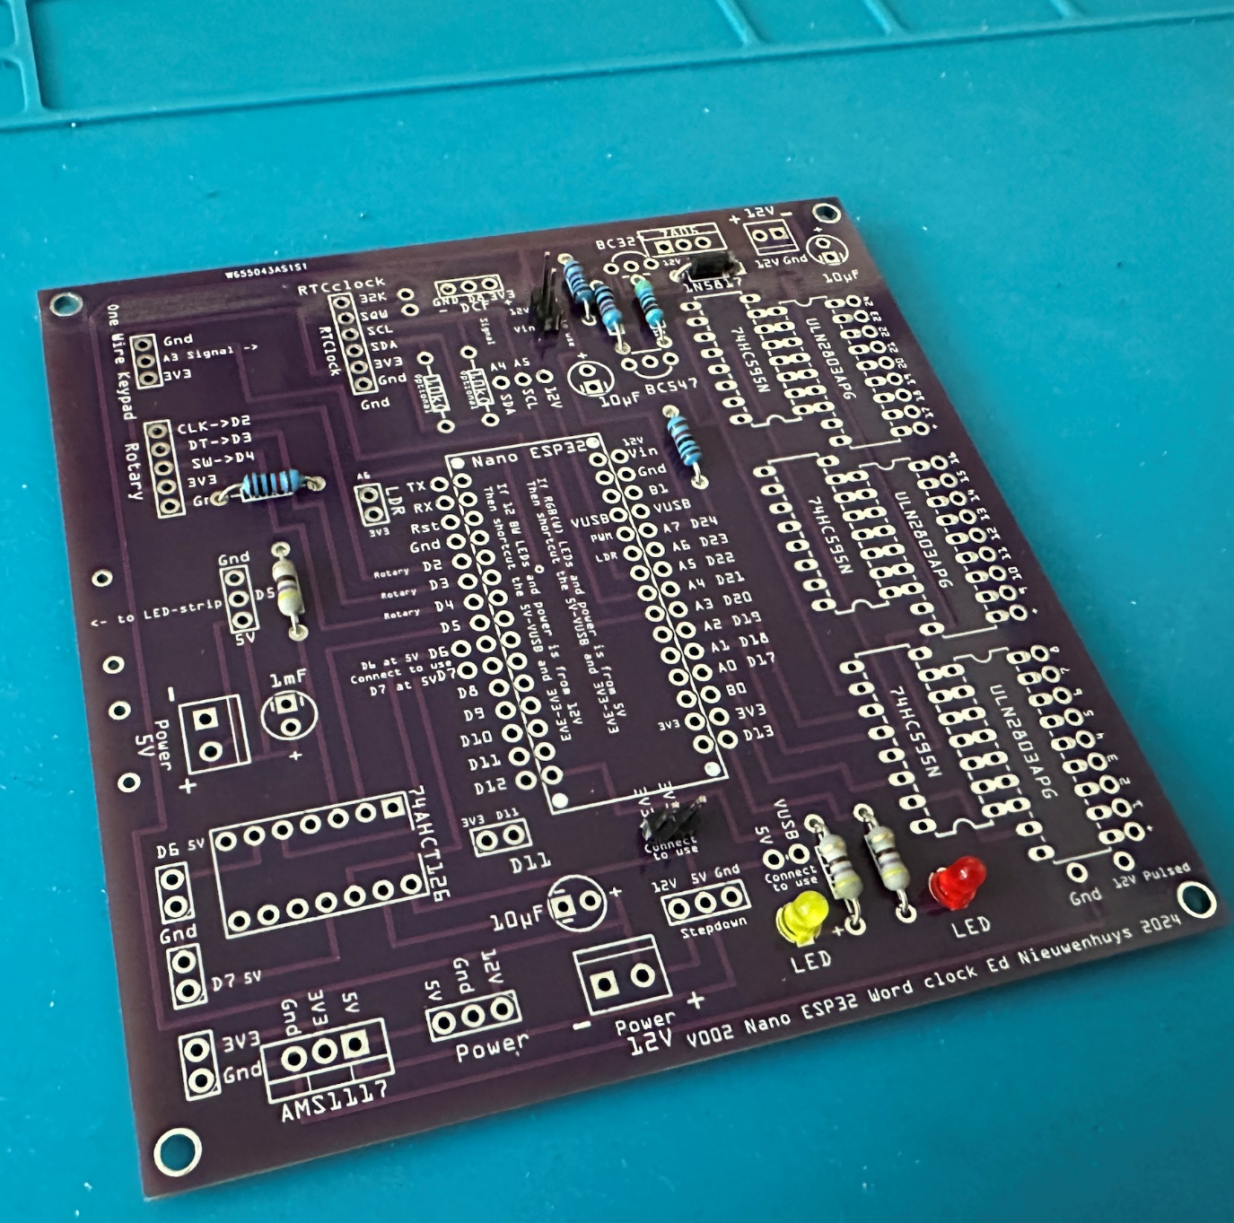  
Solder three connection pins; 3V3-3V3, 12V-Vin and VUSB-5V. The last is not soldered yet on this picture.  
Use two straight connectors that can be shortcut with a connector or solder them permanently with a wire.  
3V3-3V3 feeds the board from the Arduino 3V3. **(Default)** Open the connection when a 3V3 AMS1117 voltage regulator is fitted   
12V-Vin powers the Arduino with 12V to Vin. **(Default)**  
VUSB-5V feeds the board with 5V from a USB cable connected to the Arduino (if 12V is not used the Arduino can be powered from 5V Power to VUSB.  
  
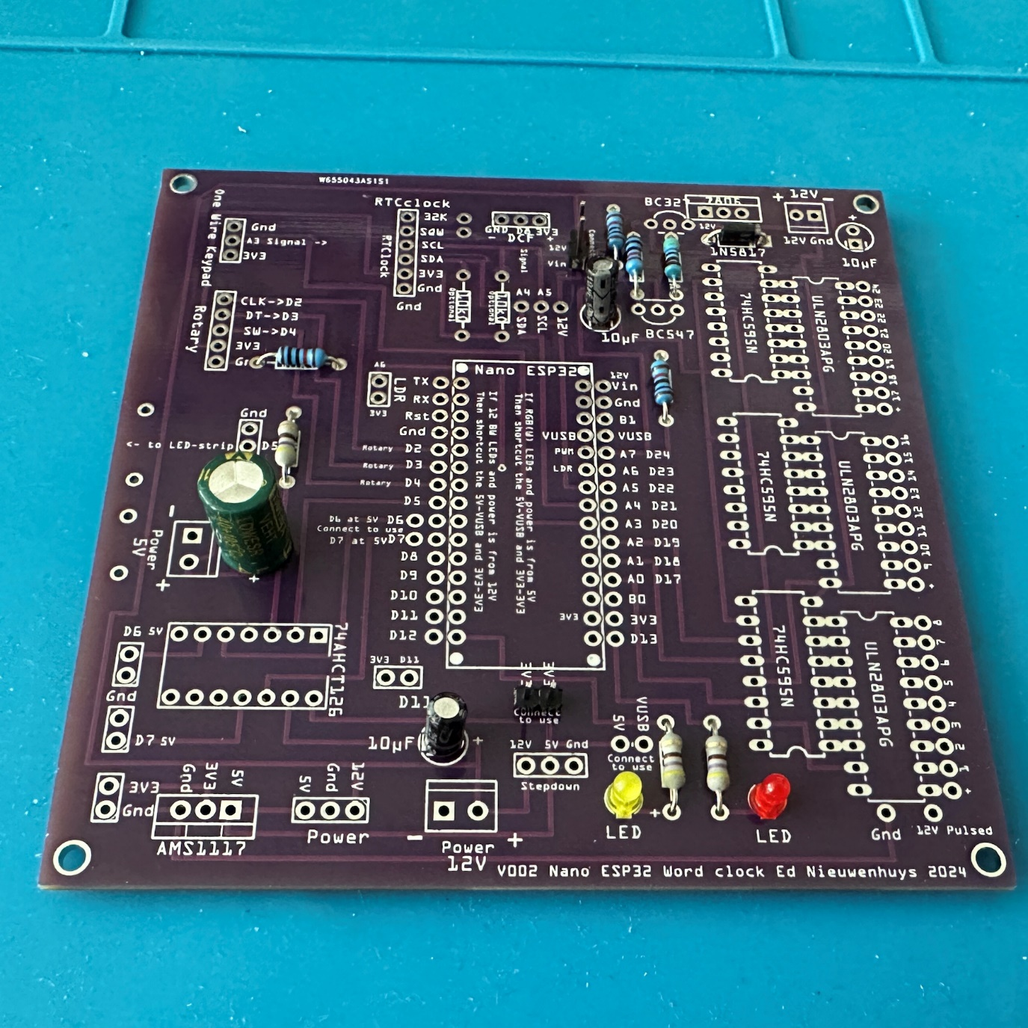 Solder the 1000 µF and three 10 µF capacitors.  
 Top right capacitor not soldered on thsi picture  
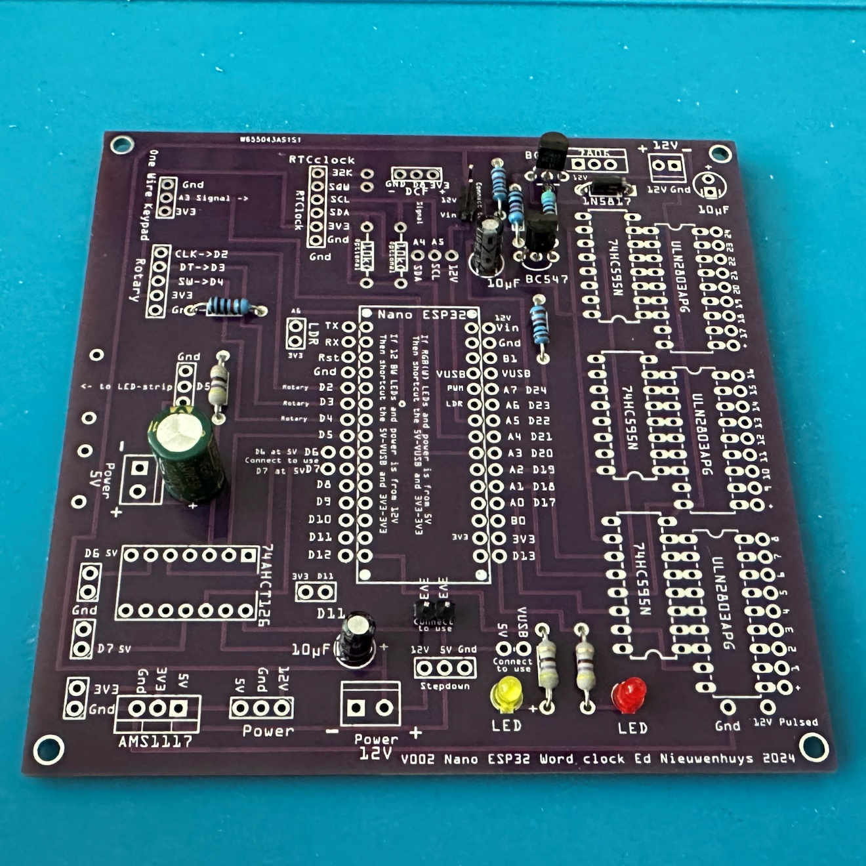  
Solder the BC327 and BC 547 transistors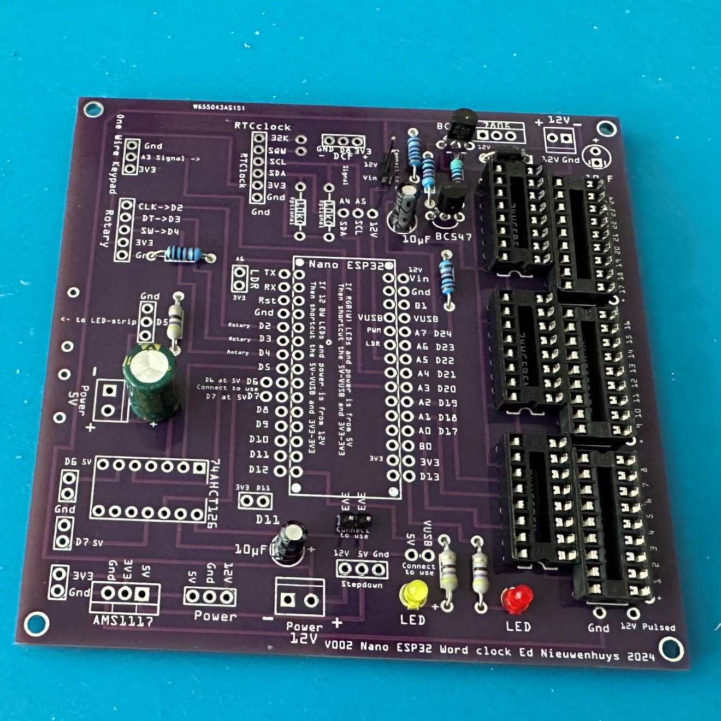Solder the ULN2803 and HC595 IC’s and notice the postion of the notches!  
  
Use IC sockets to be able to change the IC’s. It is a difficult job to desolder the IC’s when a mistake is made. 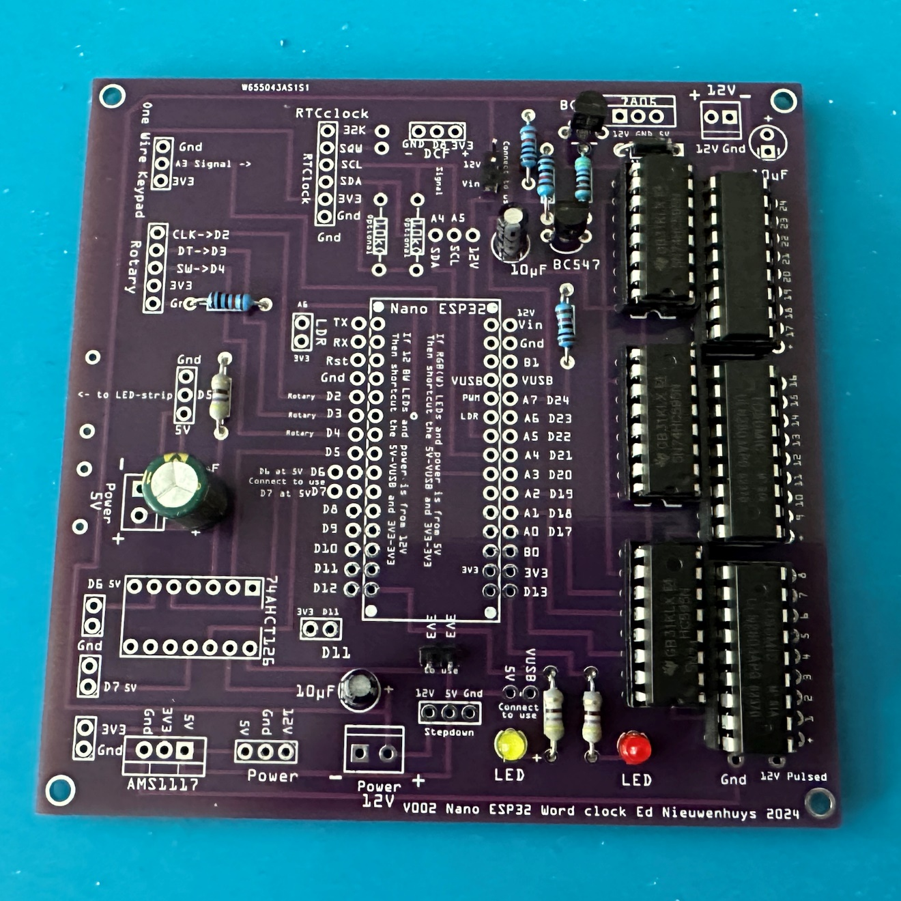 Place the IC’s and notice the postion of the notches! Place the IC’s and notice the postion of the notches!  
  
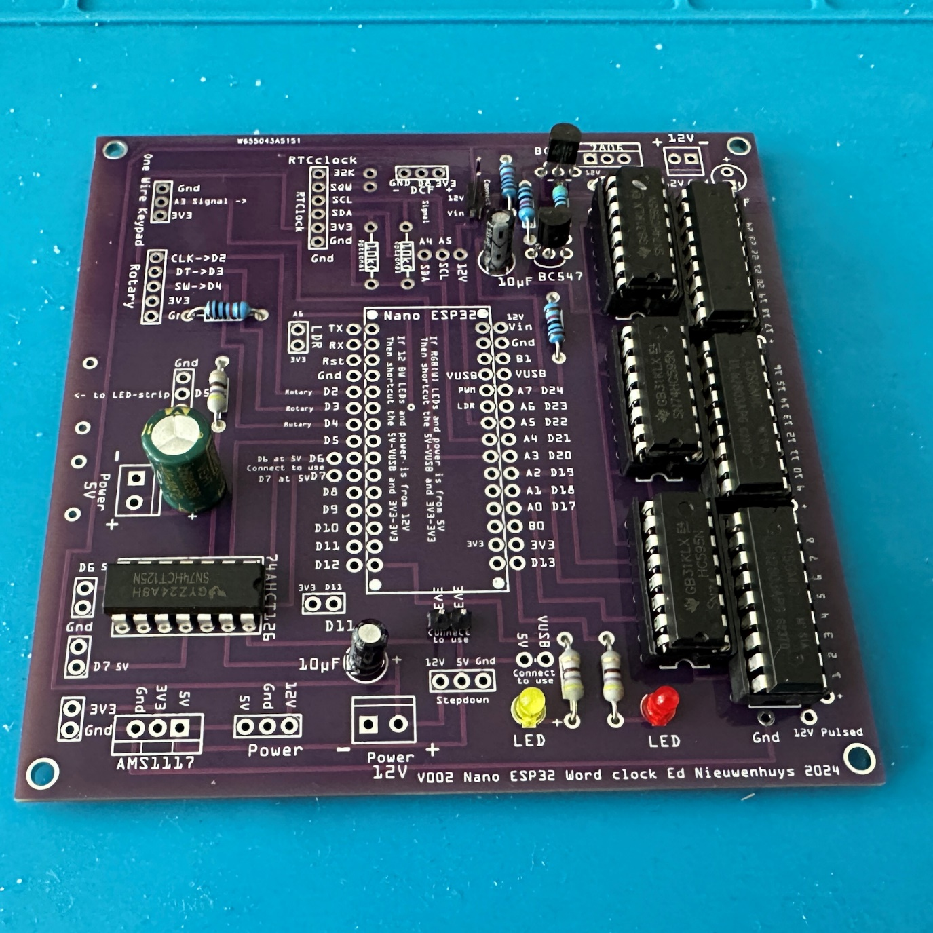 Solder the 74AHCT125 level shifter IC.  
Use IC sockets optionally. 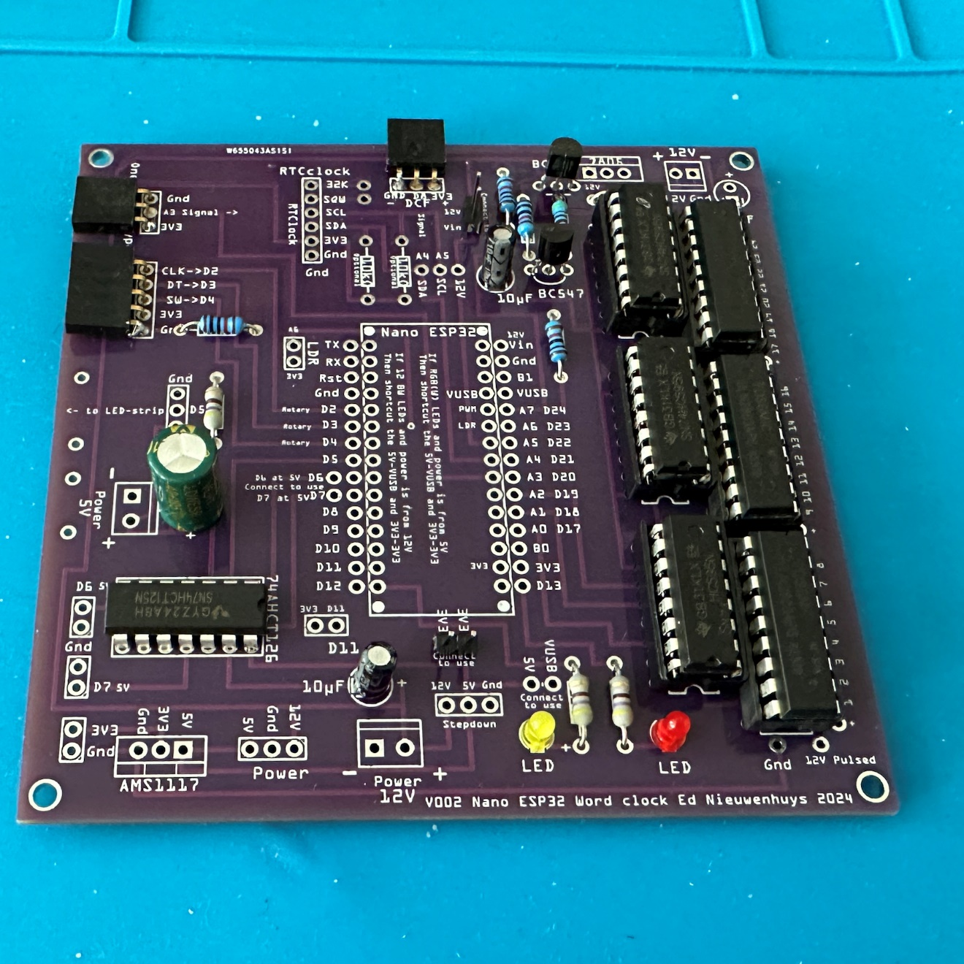 Solder the 2-, 3-, 5- and 6-pin female connectors.  
  
2-pin connector for LDR  
3-pin connectors for optional one-wire buttons and DCF77  
5-pin connector for optional rotary encoder  
6-pin connectors for optional DS3231 RTC

For testing a 3-pin connector can be used for the 7805 and the 12V to 5V stepdown regulator or whatever power supply is used

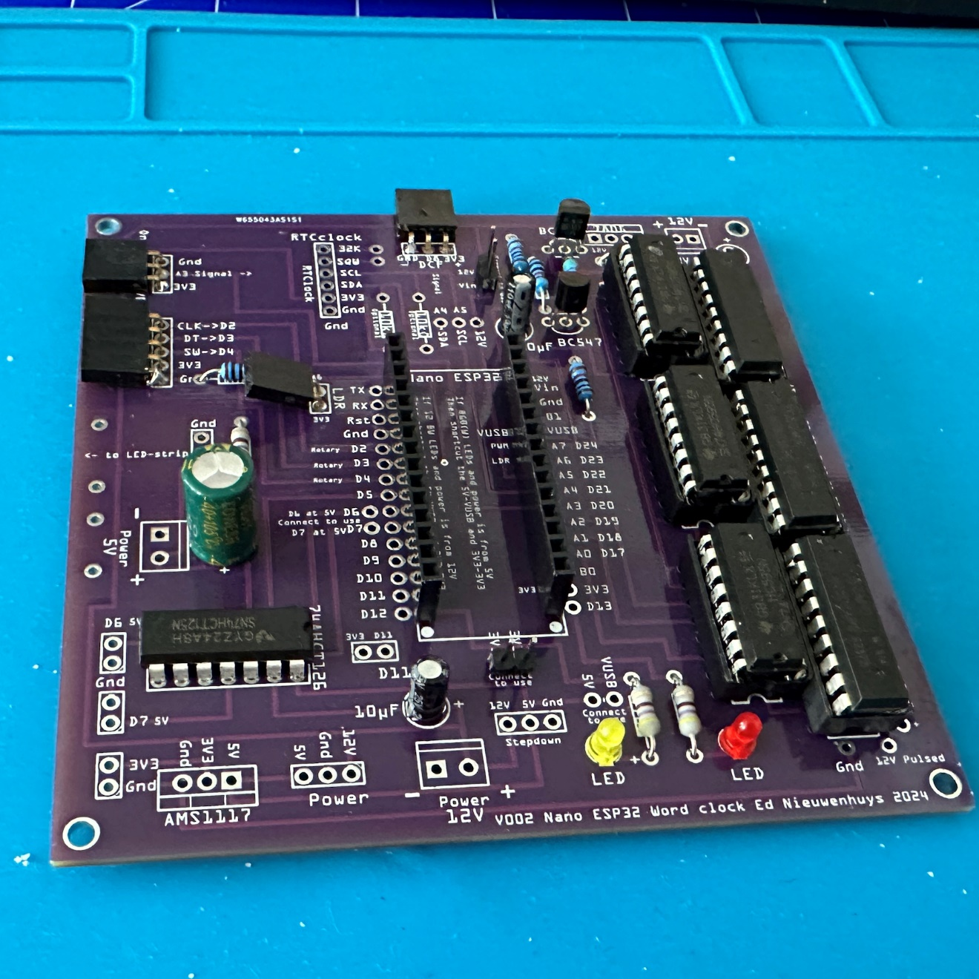 Solder the 15-pin female connectors, straight!, for the Arduino Nano ESP32. 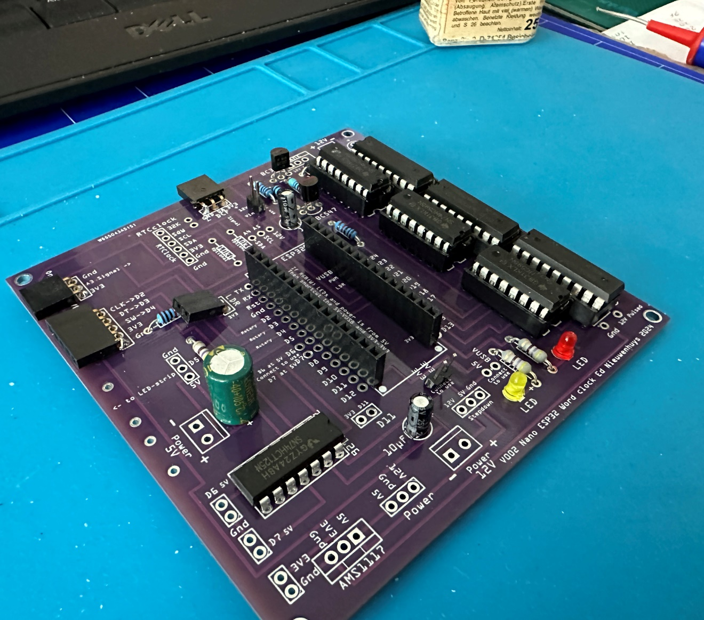 Side view.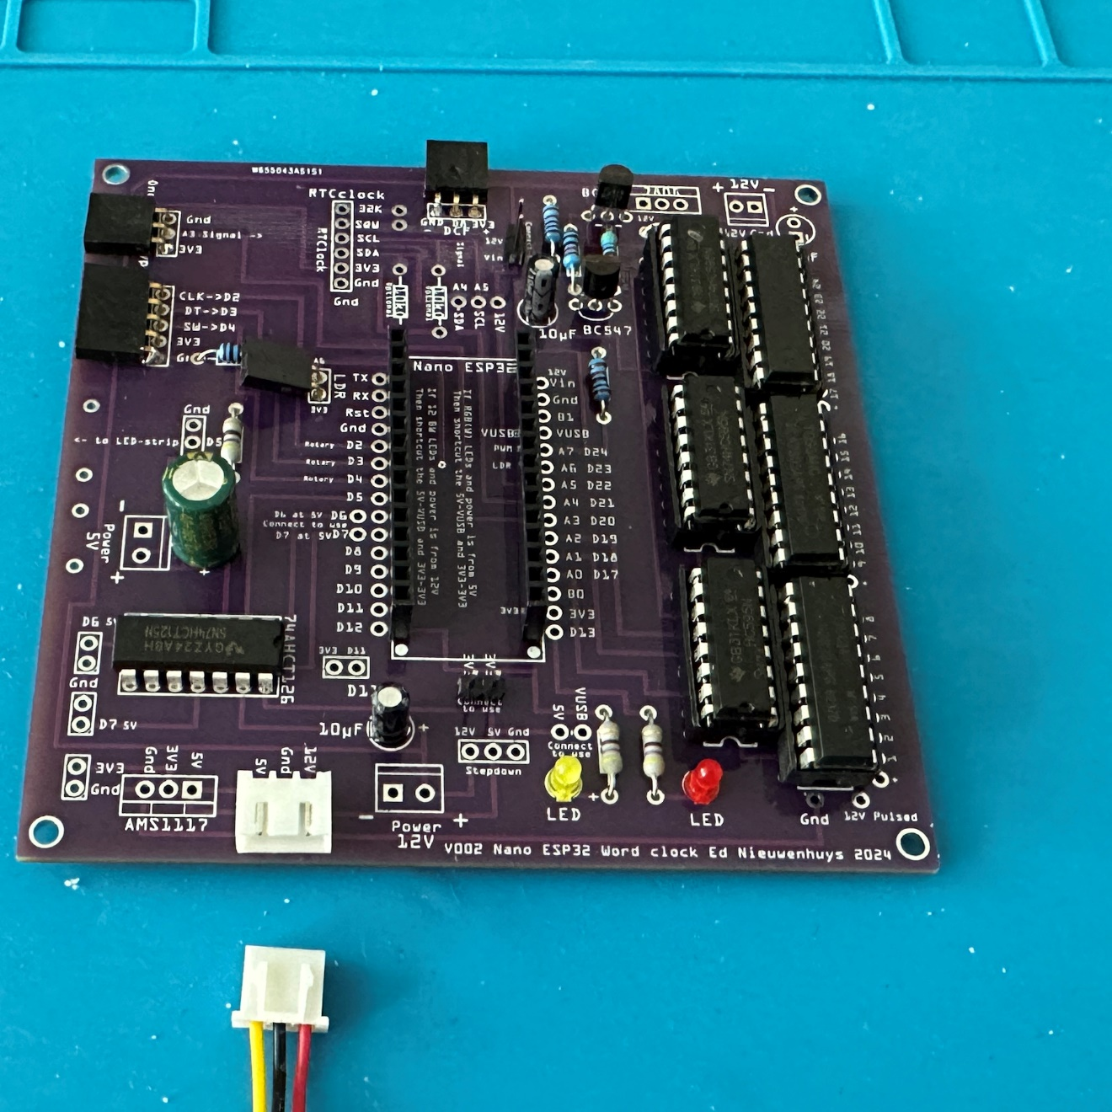   
An XH2.54 connector or other connector can be soldered for an external 5V-12V power supply instead of the voltage regulators

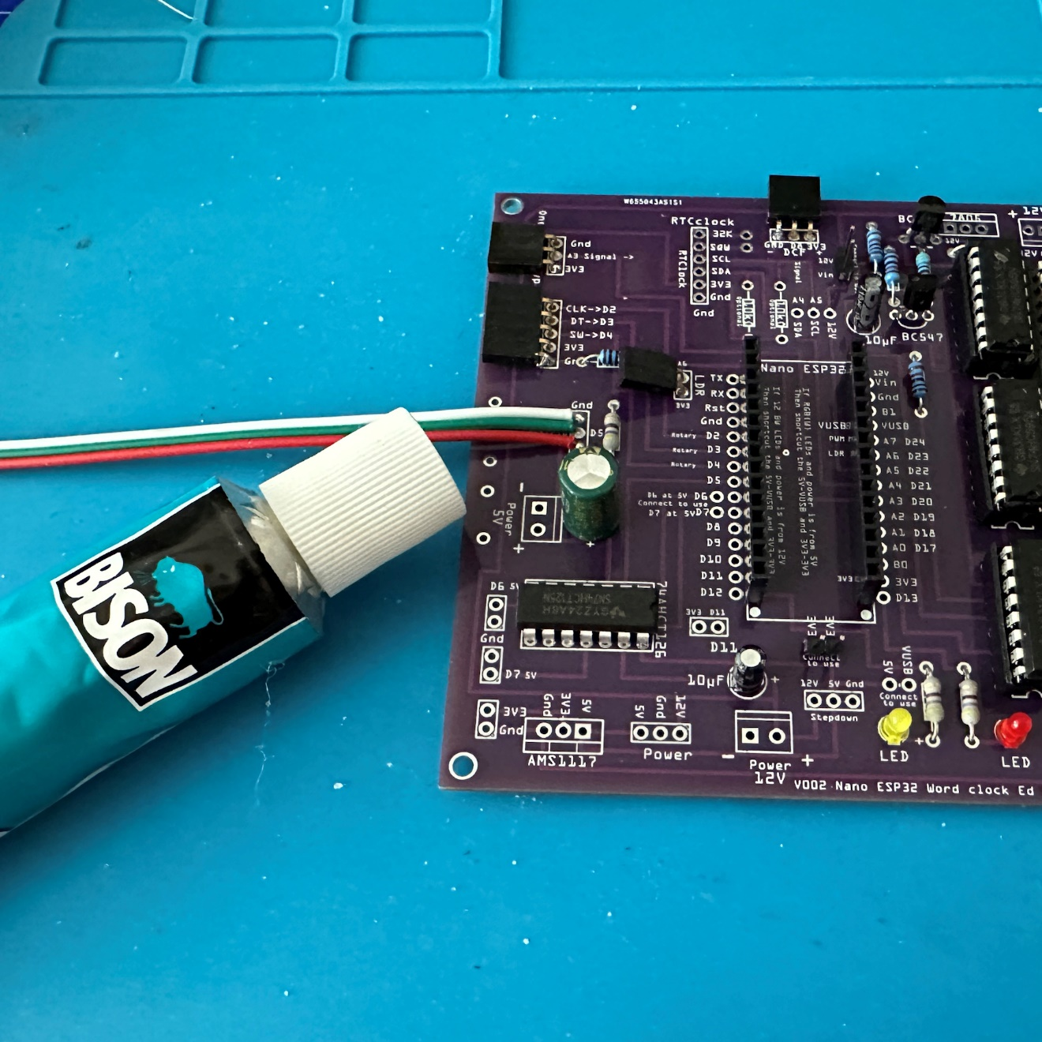 Solder the cable for the WS2812/SK6812 LED-strip. Glue it to the PCB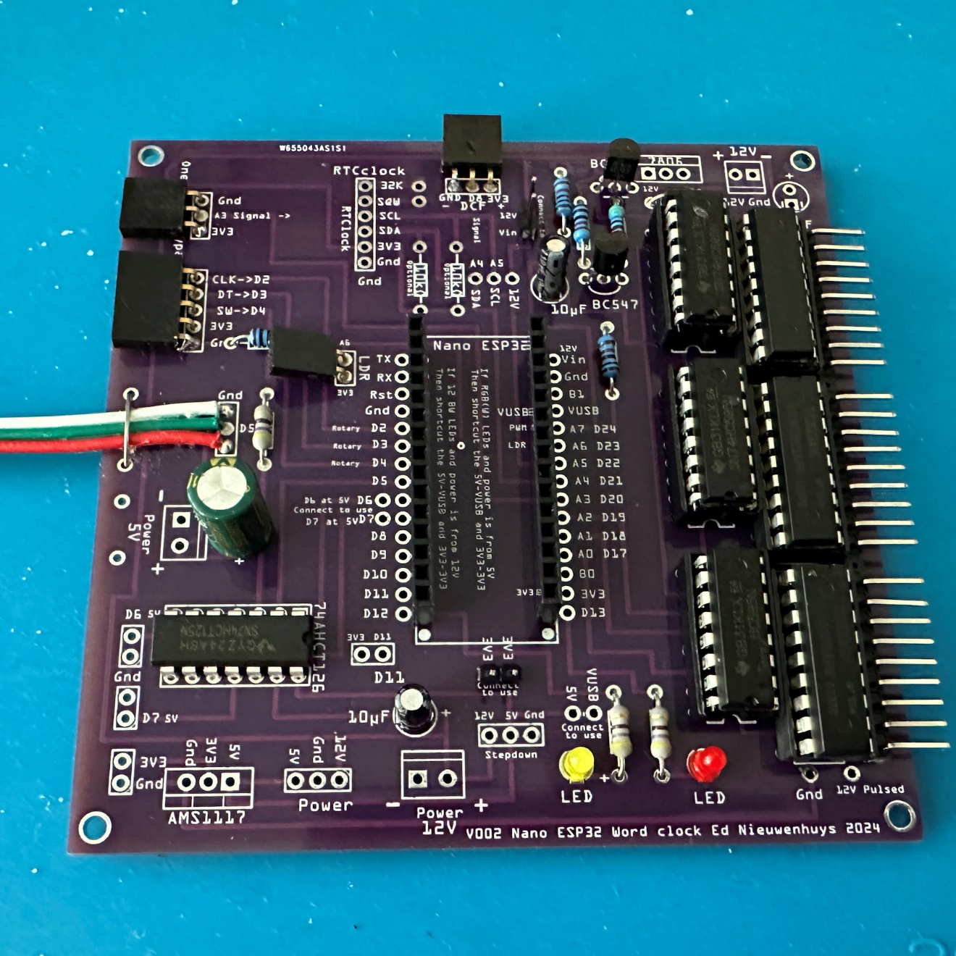 and strap it with a wire 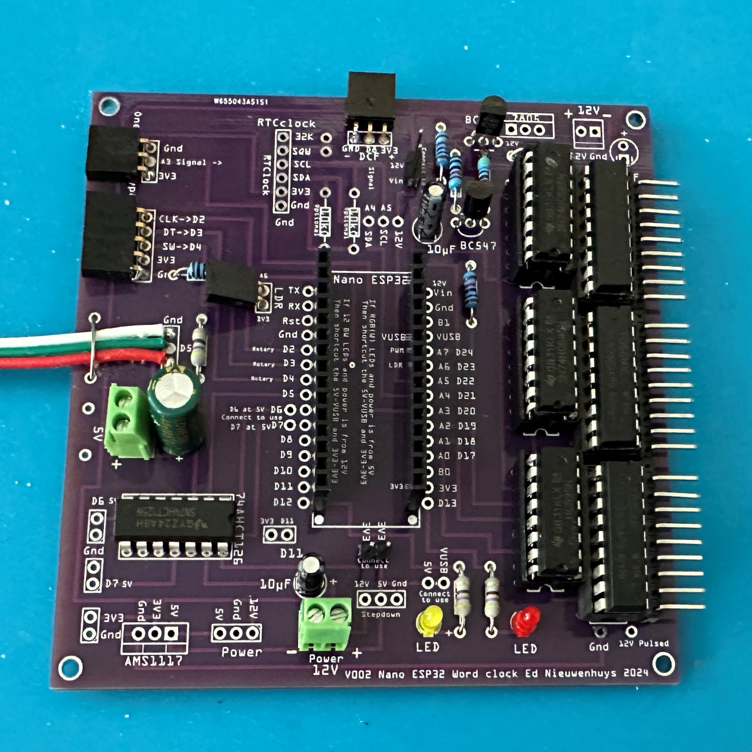 Solder the three power connectors.   
Top right connector not fitted yet. 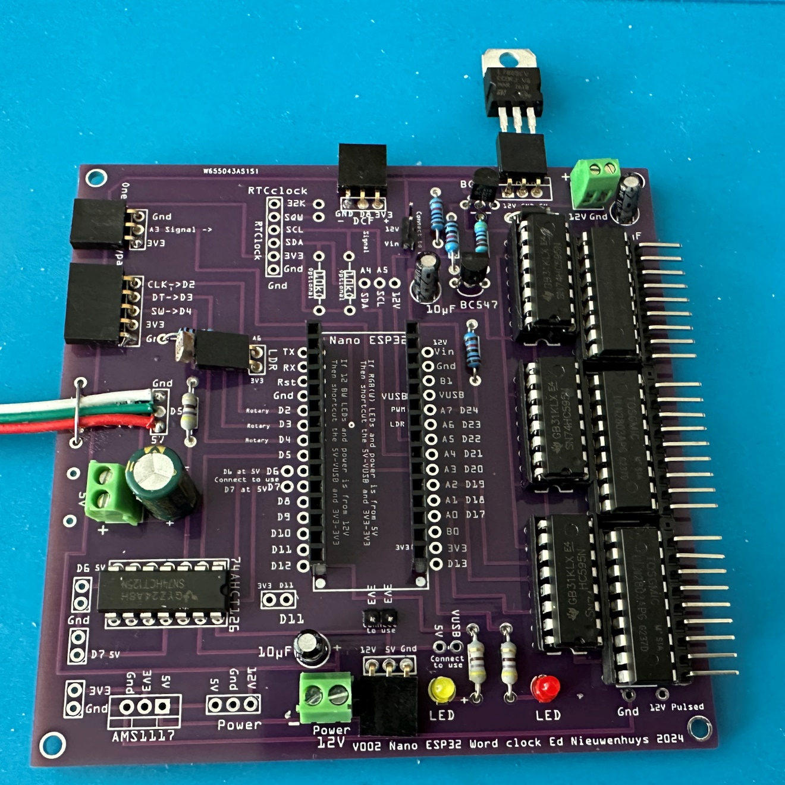  
A 7805 voltage regulator fitted in a 3-pin connector.  
Solder it preferably to the PCB for permanent use.   
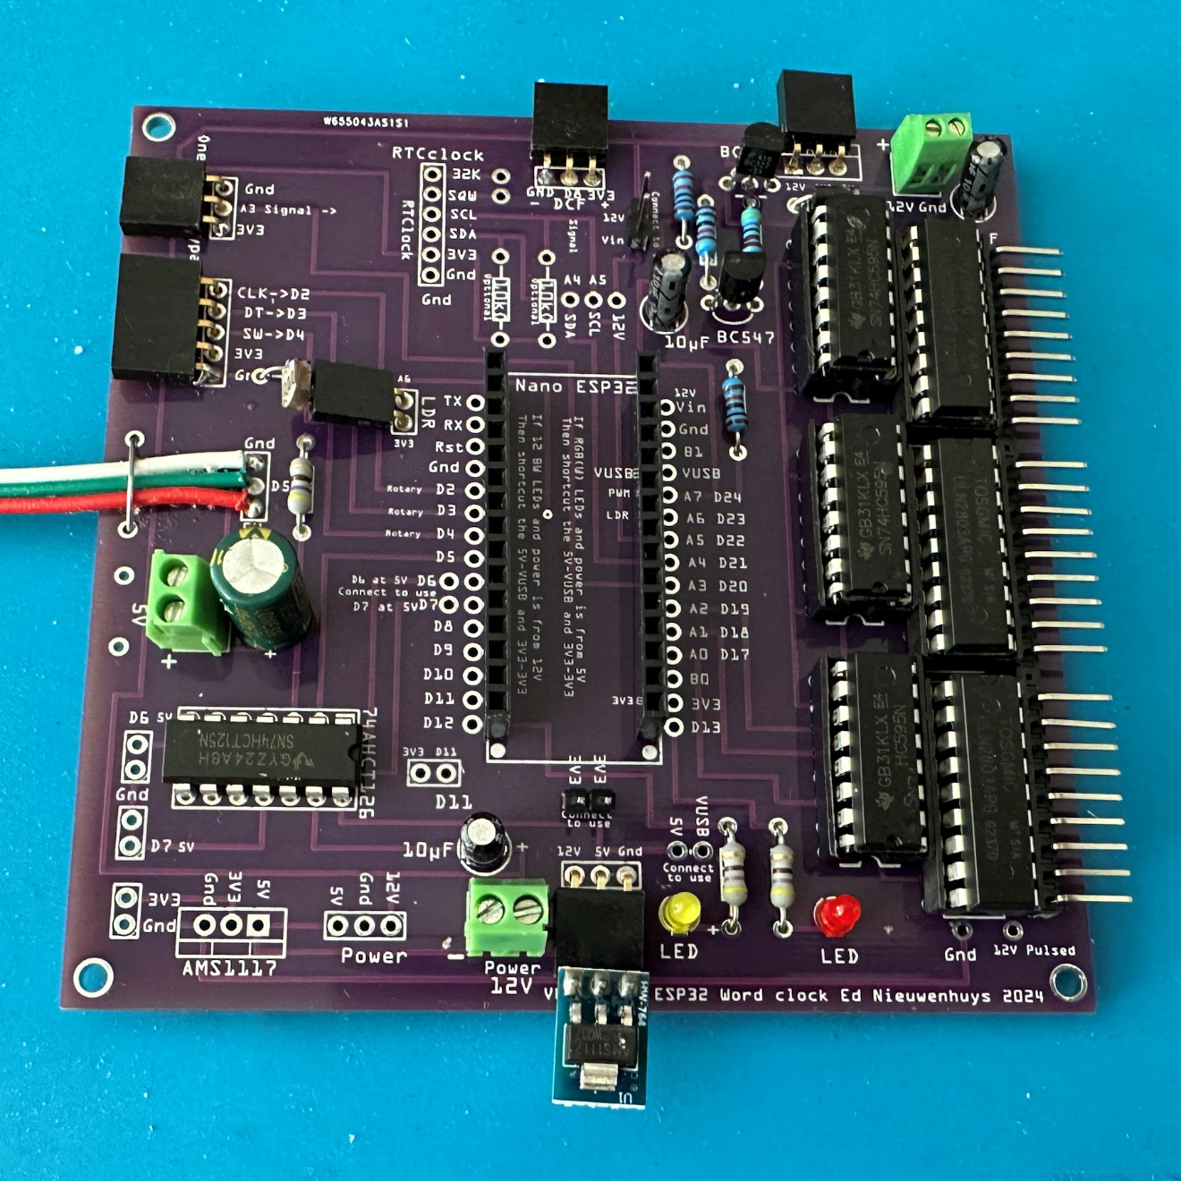 A 12V to 5V voltage regulator fitted in a 3-pin connector.  
Solder it preferably to the PCB for permanent use.   
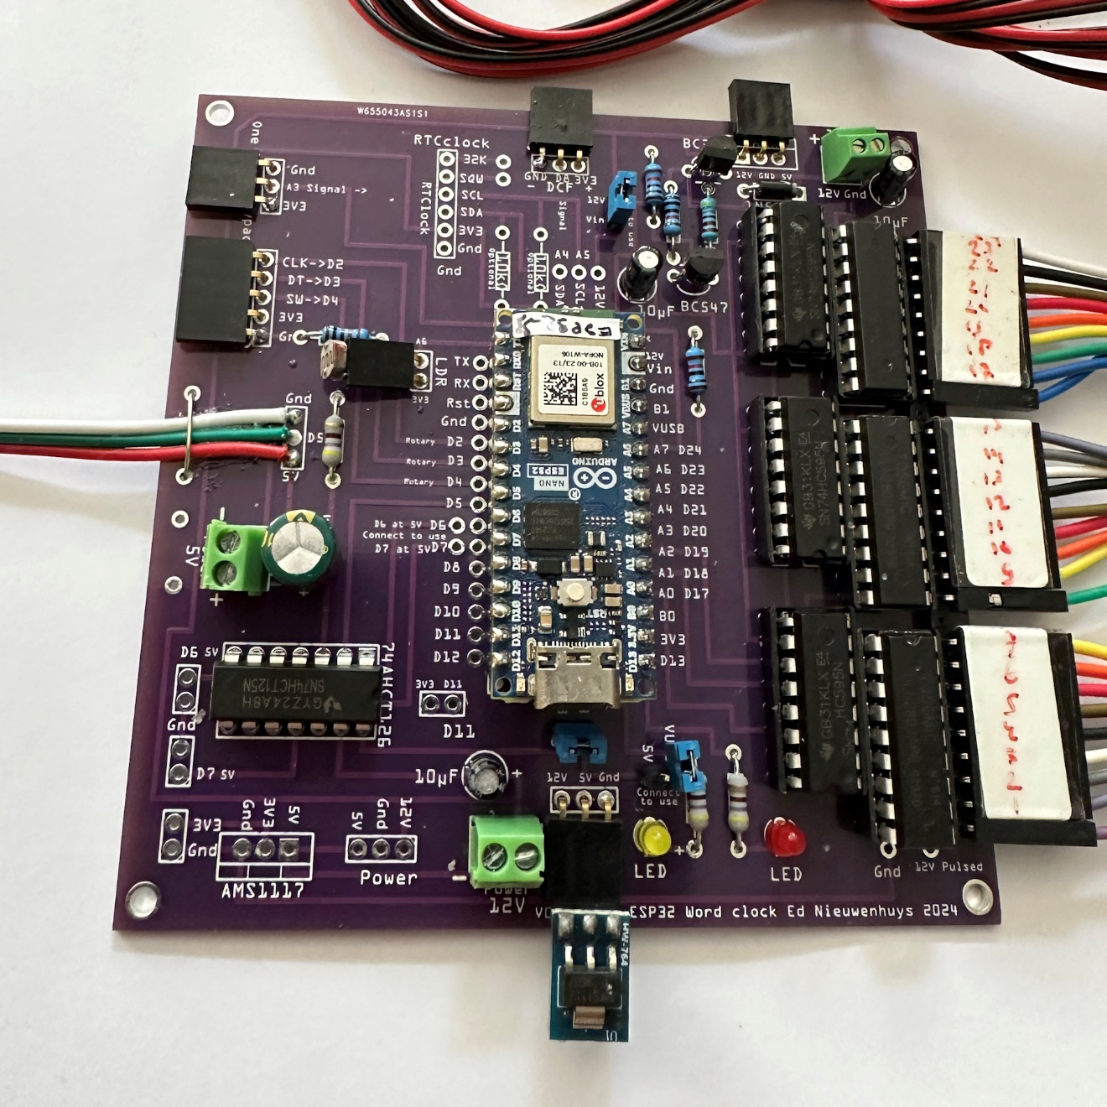 All components fitted and connections made to the 24 white 2835 / 3528 LED-strips on the right and the RGB(w) LED-strips on the left.  
  
Use the software from here to use this PCB:  
<https://github.com/ednieuw/NanoESP32-BW-RGBW-clock>

Ed Nieuwenhuys, august 2024